**Documentation For Custome Excel Export**

This module covers Excel Export of CRUD operation on Product Entity, Importing the data using API REST Services, Exporting/Downloading the Product data to excel sheet as per the user input and MX Reflection.

**Prerequisites**

* Mendix Studio Pro 9.12.5.
* Excel Export and MxModel Reflection Module from Market Place.

STEPS TO FOLLOW

1. **Download modules from marketplace**

* MxModel Reflection
* Excel Export

1. **Data Import Using API-Implementation**

API to make a REST call to retrieve data of products in a JSON format and display it in the application.

* 1. In your module, create a microflow to retrieve data from a link using API.
  2. For the microflow that will have the logic to make the REST call to retrieve the data is created, we need to create a JSON structure that will indicate how we are going to be receiving the data from the API.
  3. Now, in [JSON Placeholder page](https://jsonplaceholder.typicode.com/), look for /users in resources and open it in a new tab in your browser. Copy the JSON that is displayed and then paste it in the JSON structure content and Format the content.
  4. Now in the created microflow add activity to call Rest services and set the link of data to the location. In the Response tab, choose Import from mapping and provide the variable.
  5. The final microflow will look like this.

* 1. Go to “Home_Web” page, add a Data Grid widget in the Layout grid.
  2. Click on the Data Grid and go to Data Source and select microflow, then select the microflow that we created.
  3. Select Yes to automatically fill data and for the server-side paging.
  4. Save files and run locally.
  5. The final page will look like this.

1. **Adding Export button**

Reference : [Mendix Academy - 7.1 Using the Excel Exporter to Export Data](https://academy.mendix.com/link/modules/136/lectures/1252/7.1-Using-the-Excel-Exporter-to-Export-Data)

* 1. Click on the reference and do as per given. After doing this you need to do some modification.
  2. In the domain model add a attribute HideSheet as a string.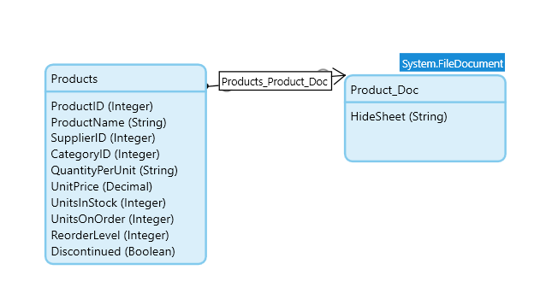
  3. Create a page name it Hidesheet_Overview
  4. Copy GenerateExcelDoc from Marketplace module > XLSReport > Documents > Java Actions and paste it in the MyFirstModule and name it HideExcelDocs.
  5. Open HideExcelDocs java action and add a parameter HideSheet of type String.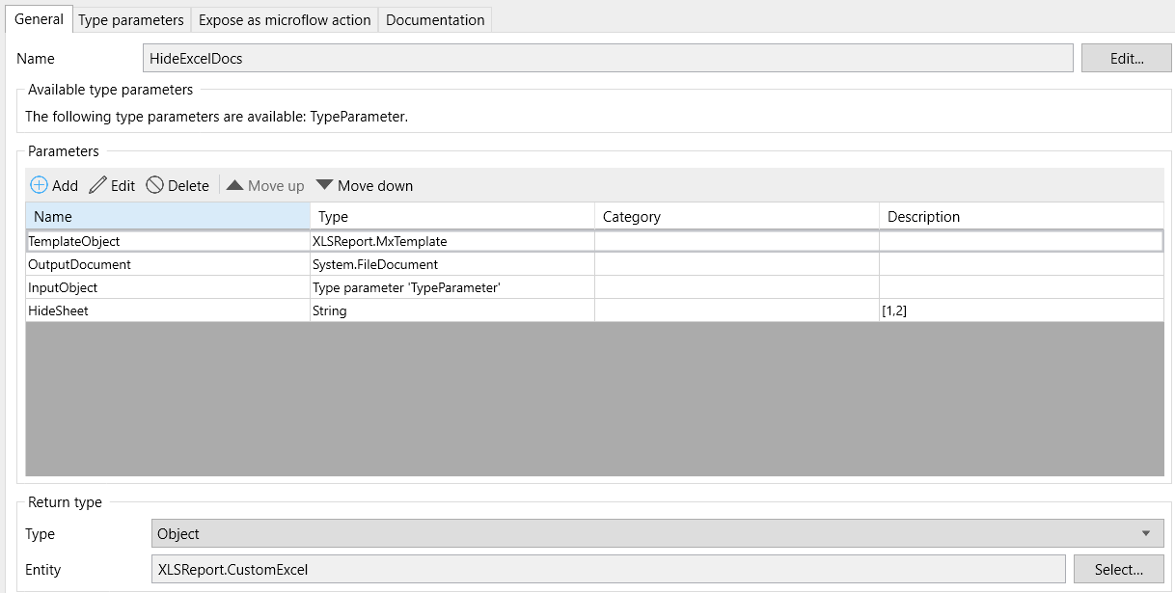
  6. Now open microflow ACT_Export_To_Excel add a parameter of object type Product_Doc and click ok.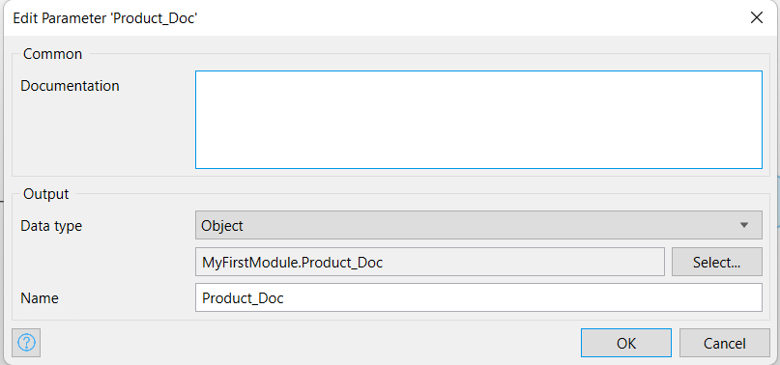
  7. 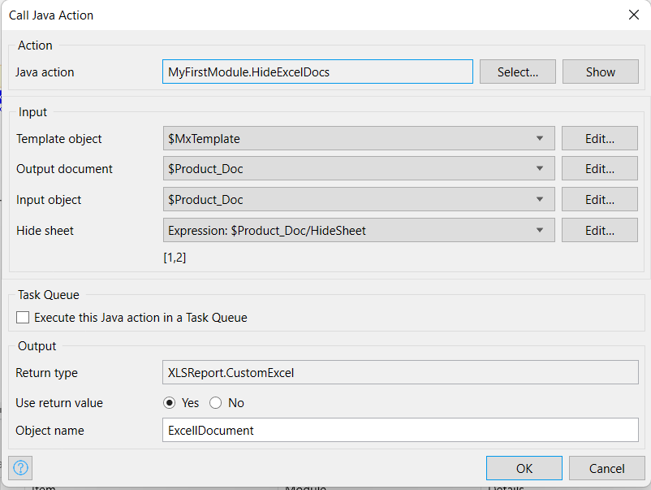Instead of GenerateExcelDoc java action replace it with the HideExcelDocs. In the output Document select Product_Doc and in Input Object select Product_Doc and in the HideSheet click edit and pass an argument : $Product_Doc/HideSheet and click ok. After doing this it should like the below image
  8. 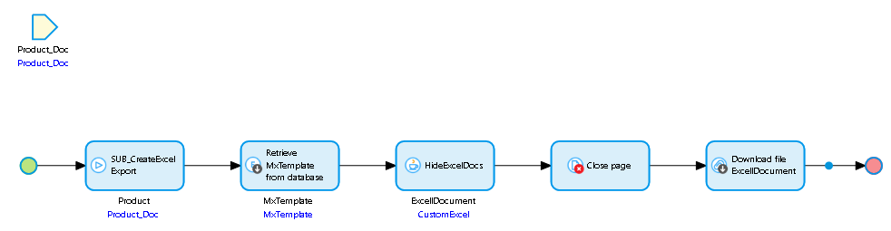Add a close page after this. Now the modified microflow will look like the below image, if you have followed the steps properly.

1. Deploy the code to eclipse.
   1. Go to App > Click on Deploy for Eclipse

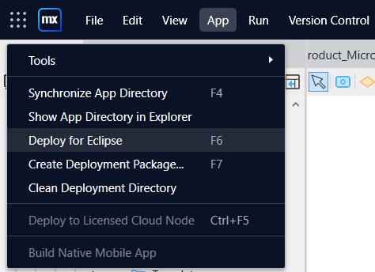

* 1. Open eclipse and import it. I hope you know this. If you don’t know, you can search on internet you can easily get lot of details on how to import it.
  2. Go to JavaSources> xlsreport.report.export. Copy ExportExcel.java and paste it in myFirstModule.actions. Rename it to ExportExcelDemo.java or any name you want. After that it would look like the below image.

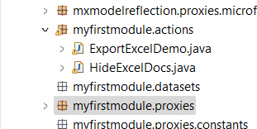

* 1. Go to ExportExcelDemo.java . Change the constructer name to ExportExcelDemo and add a attribute String hideSheets to it. It will look like the below image.

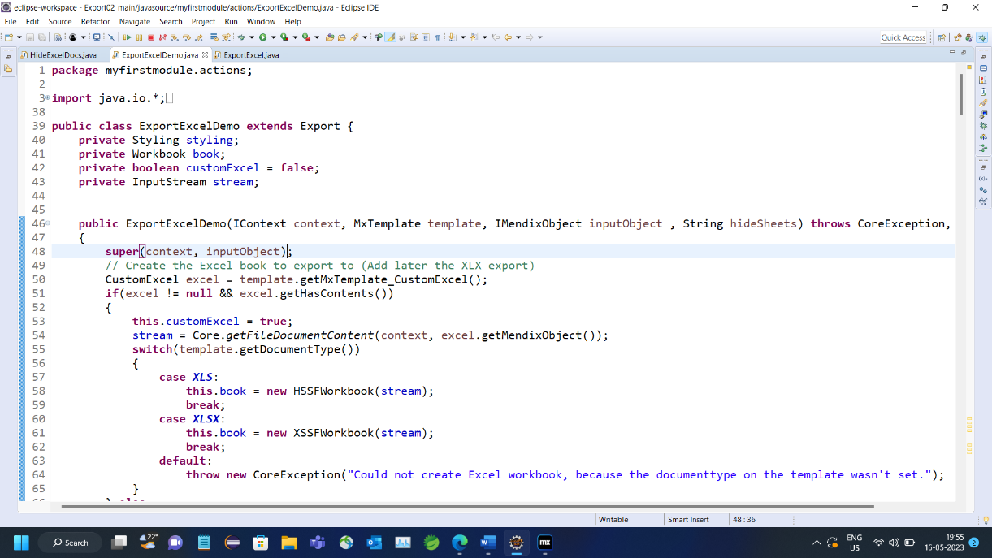

* 1. Now add a piece of code below line 80. You can apply your own code but I have provided the code below :

*this.book.setForceFormulaRecalculation(true);*

*if(hideSheets != null && hideSheets.length() > 0) {*

*String[] hideSheetNumbers = hideSheets.split(",");*

*for (String s: hideSheetNumbers) {*

*//Do your stuff here*

*this.book.setSheetVisibility(Integer.parseInt(s), SheetVisibility.VERY_HIDDEN);*

*System.out.println(s);*

*}*

*}*

* 1. After doing this it will look like the below image:

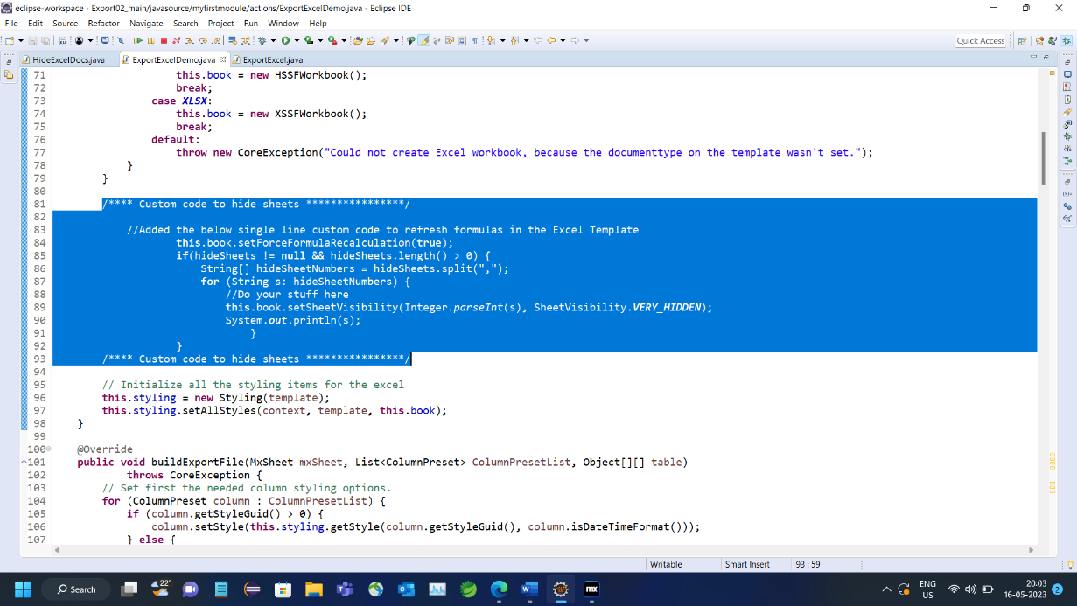

* 1. Now open HideExcelDocs.java and go to method createExport(). You will find this in line 190. Change the object name from ExportExcel to ExportExcelDemo. See the below image for better understanding. Now run the application.

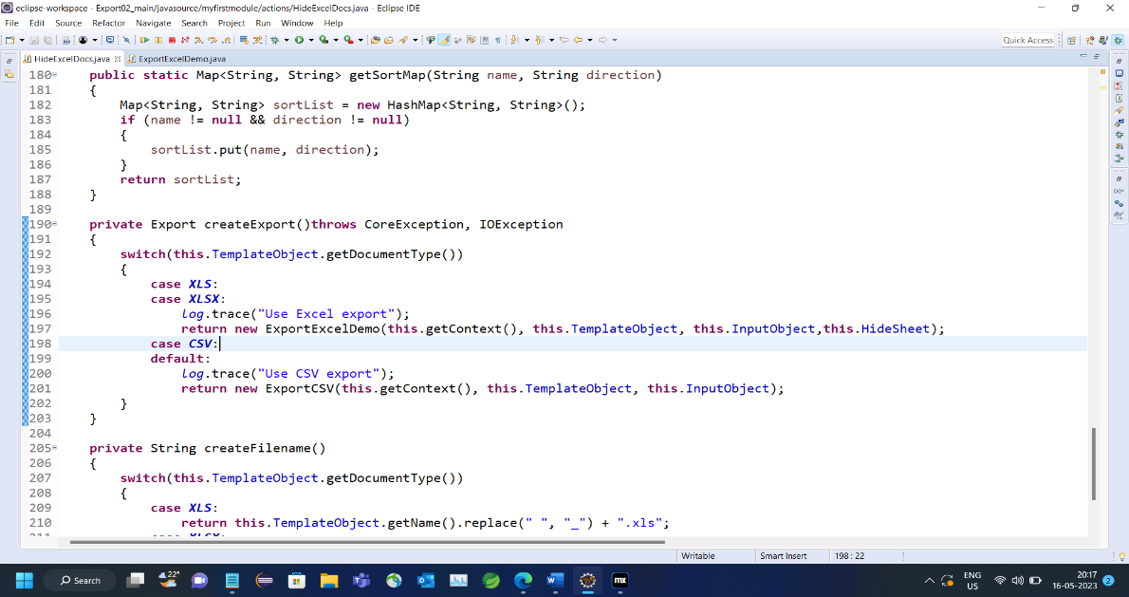

5) Complete.